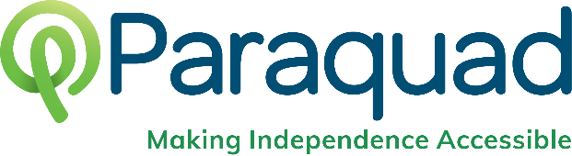
Advocating for Change
Additional Resources
2022 Independent Living Summit

For a comprehensive glossary of Missouri legislative terminology:
https://mffh.org/wp-content/uploads/2016/04/Missouri-General-Assembly-Glossary-of-Legislative-Terminology.pdf
Missouri Legislative Process
House Resource
https://house.mo.gov/billtracking/info/howbill.htm
Senate Resource
https://www.senate.mo.gov/bill-law.htm
Lobbying Guidelines for 501(c)(3) Public Charities
https://bolderadvocacy.org/wp-content/uploads/2018/06/Public-Charities-can-Lobby-4.20.21.pdf
Is this lobbying? (Flowchart)
https://bolderadvocacy.org/wp-content/uploads/2018/06/Lobbying-Flowchart.pdf
Staying Nonpartisan During Election Season
https://bolderadvocacy.org/wp-content/uploads/2020/10/Keeping-Nonpartisan-During-Election-Season.pdf
Missouri Voter Information
Check your registration and register online:
https://www.sos.mo.gov/elections/goVoteMissouri/register
Voting rights FAQ:
https://www.sos.mo.gov/elections/goVoteMissouri/votingrights
Missouri State Budget Resources
Introduction to Missouri’s State Budget 2022
https://www.mobudget.org/wp-content/uploads/2022/03/MO-Budget-Overview-2022.pdf
Budget Basics: Community Services for Seniors & People with Disabilities FY 2022
https://www.mobudget.org/wp-content/uploads/2022/03/Senior-Services-2022-Budget-Primer.pdf
Community Catalyst’s Guide to Building a Grassroots Organizing Program
https://www.communitycatalyst.org/resources/publications/document/2017/ItsAllAboutTheBase-Report-FINAL.pdf
Questions?
Briana Conley; Public Policy & Youth Services Manager
314.289.4304/bconley@paraquad.org
Carrie Scherr; Organizing & Advocacy Specialist
314.289.4352/cscherr@paraquad.org

